HNSW and IVFFlat

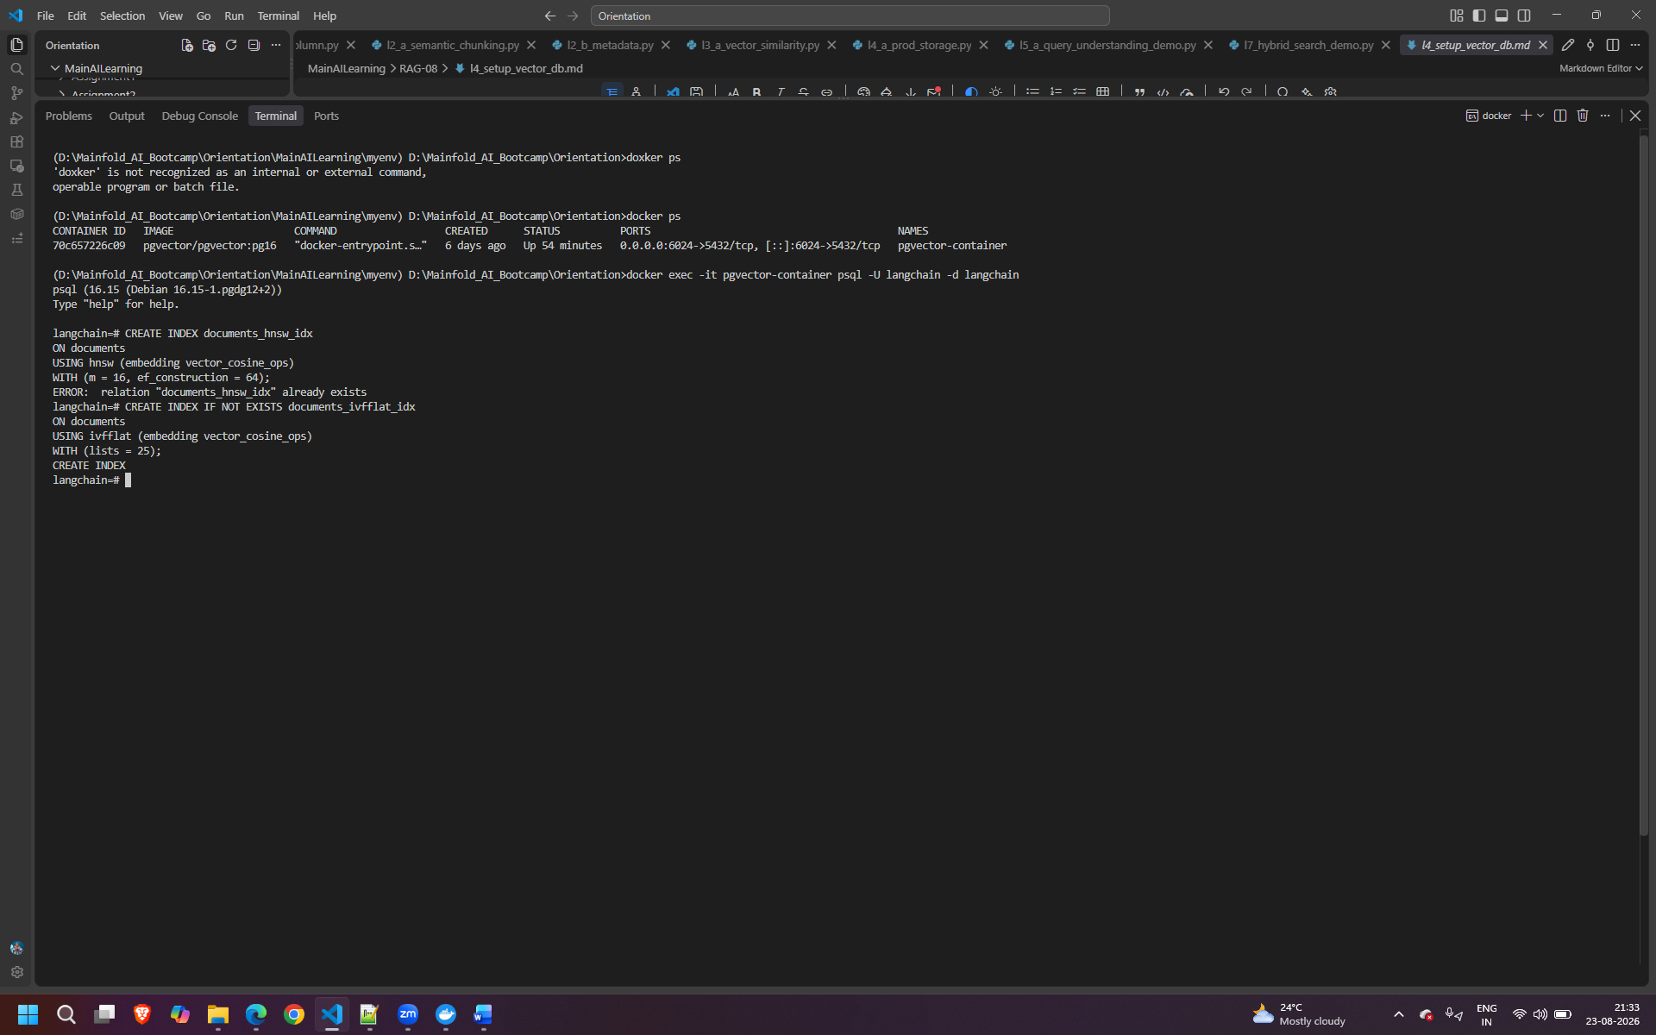

Running record manager
